Airline Level Analysis:

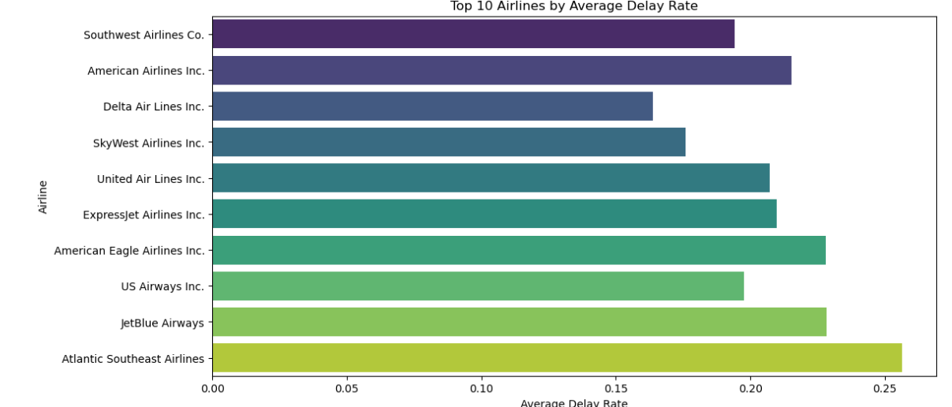
Observations & Interpretation
- Total Flights vs Total Delays
  - Southwest Airlines has the highest number of total flights (22M) and correspondingly the highest absolute number of delays (4M).
  - Absolute delay counts are heavily influenced by flight volume — more flights generally mean more total delays.
- Delay Rate (Proportion of Flights Delayed)
  - Atlantic Southeast Airlines has the highest delay rate (0.256, ~25.6%), even though it flies far fewer flights (2.5M).
  - Delta has the lowest delay rate among large carriers (0.164), showing relatively better operational reliability.
  - Interpretation: Delay rate is more meaningful for comparing reliability than total delays, because it accounts for flight volume.
- Average Delay per Delayed Flight
  - JetBlue Airways (59.2 min), United (58.6 min), and SkyWest (58.3 min) have longer average delays per delayed flight.
  - US Airways (45.2 min) and Southwest (47.6 min) have shorter average delays, indicating quicker recovery or less severe delays.
  - Insight: Some carriers may have fewer delays overall but when they occur, the delays are longer, suggesting severity issues.
- Patterns by Carrier Type
  - Major network carriers (Delta, United, American) have moderate delay rates but higher average delay minutes.
  - Regional or smaller carriers (Atlantic Southeast, SkyWest) have higher delay rates, sometimes with high average delay minutes.
  - Interpretation: Regional carriers might have less scheduling flexibility or aircraft rotation issues, leading to higher delay probability.
Key Insights
- Southwest Airlines: High volume, moderate delay rate, low average delay — operationally consistent.
- Atlantic Southeast Airlines: High delay rate despite smaller operations — reliability concern.
- Delta: Low delay rate but slightly higher average delay — generally reliable.
- JetBlue & United: Longer delays per delayed flight — when delays occur, they are more disruptive.
- American Eagle & ExpressJet: High delay rates (~21–23%) — regional/feeder carriers may need better scheduling strategies.

Airport Level Analysis:
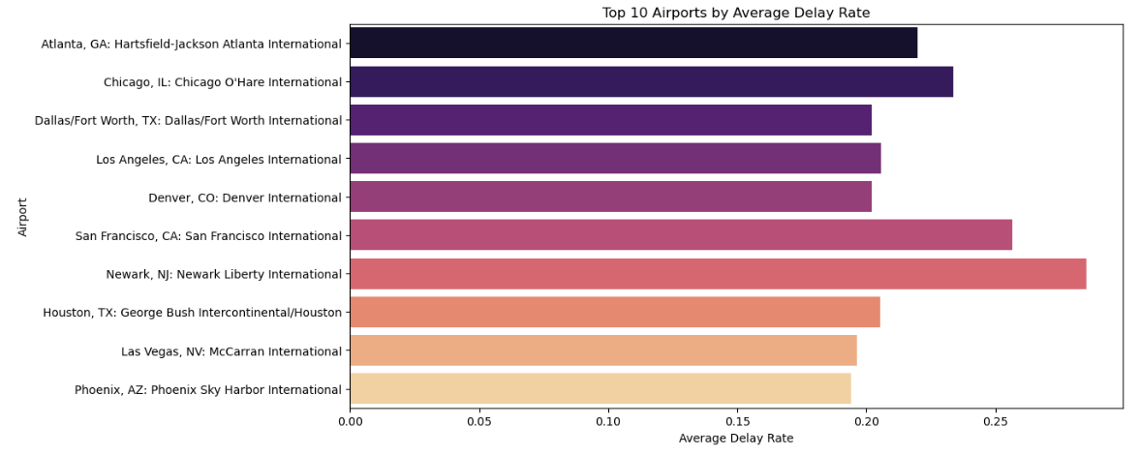
Observations & Interpretation
- Total Flights vs Total Delays
  - Atlanta (ATL) has the highest total flights (7.26M) and the highest absolute delays (1.33M).
  - Chicago O’Hare (ORD) is second in both volume and total delays.
  - Insight: Absolute delays largely follow flight volume — major hubs naturally experience more delays.
- Delay Rate (Proportion of Flights Delayed)
  - Newark (EWR) has the highest delay rate (0.285, ~28.5%), despite being mid-sized compared to ATL or ORD.
  - San Francisco (SFO) also has a high delay rate (~25.6%).
  - Phoenix (PHX) and Las Vegas (LAS) have the lowest delay rates (~19–19.5%), showing better reliability.
  - Insight: Delay rate is more meaningful than total delays for airport reliability assessment.
- Average Delay per Delayed Flight
  - Chicago (ORD, 65.7 min) and Newark (EWR, 65.5 min) have the longest delays per delayed flight, indicating more severe delays when they occur.
  - Los Angeles (LAX), Denver (DEN), Houston (IAH) have moderate average delays (~51–54 min).
  - Phoenix (PHX) and Las Vegas (LAS) have shorter average delays (~52–53 min).
  - Insight: Some airports have relatively fewer delays but longer disruptions, which could affect connections and operations.
- Patterns by Airport Type
  - Major hubs (ATL, ORD, LAX, DFW) have high volume but varying delay rates.
  - Coastal or weather-prone airports (EWR, SFO) have higher delay rates and longer delays, possibly due to weather and airspace congestion.
  - Smaller domestic hubs (PHX, LAS) show lower delay rates and moderate delay severity.
Key Insights
- Atlanta (ATL): High volume, moderate delay rate (~22%), average delay ~57 min — hub efficiency is decent.
- Chicago (ORD) & Newark (EWR): High delay rate and long average delays — reliability concern, especially for connecting flights.
- San Francisco (SFO): High delay rate (~25.6%) — likely affected by weather and airspace congestion.
- Phoenix (PHX) & Las Vegas (LAS): Low delay rates (~19%) and shorter delays — consistently reliable.
- Major hubs vs smaller hubs: Big airports dominate absolute delays, but delay rate and average delay per delayed flight reveal which airports are truly reliable operationally.

